**Experiment no 2 & 3:-**

**Importing the legacy data from different sources and loading in the target system.  
Creation of the Data staging area for the selected database and to perform Extraction Transformation and Loading (ETL) process using Microsoft SQL Server Integration Services SSIS .**

Step 1:- Open Microsoft sql server management studio and than connect it.

Than click on database and than new database

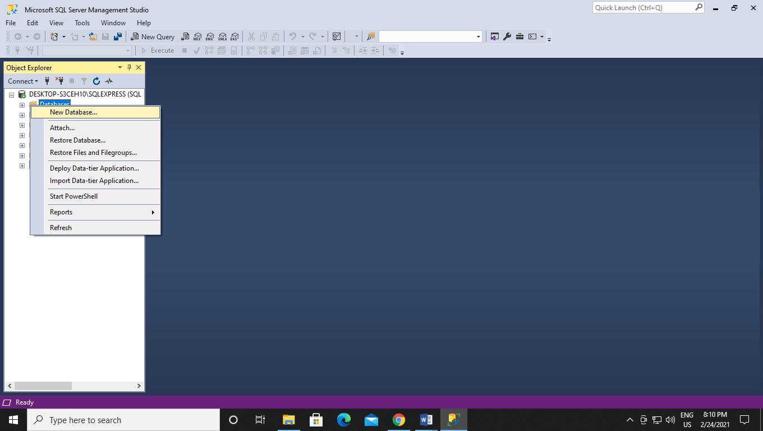

Step 2 :- Enter the name of database and click ok.

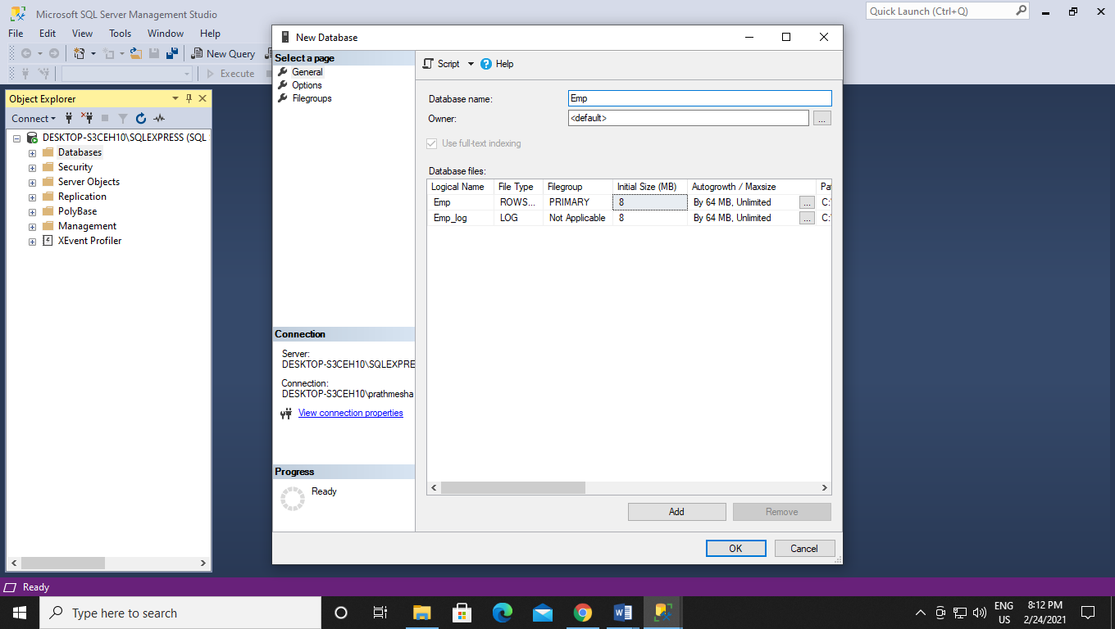

Step 3 :- now go to table and click than select new than table.

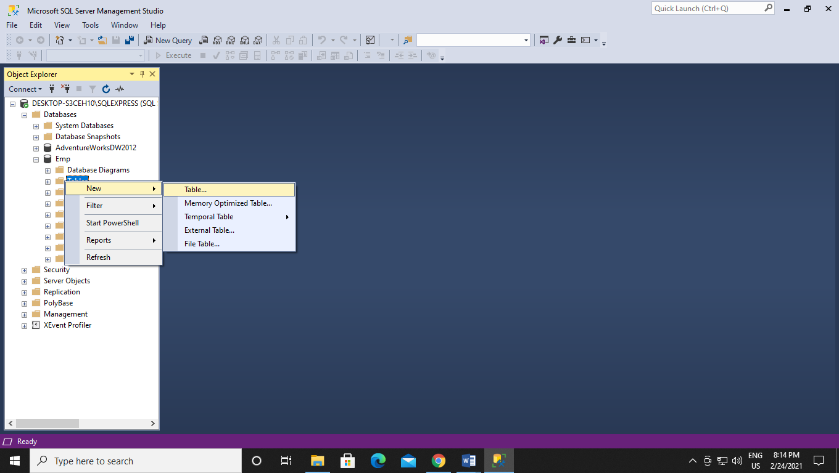

Step 4 :- Enter the column name and the datatypes.

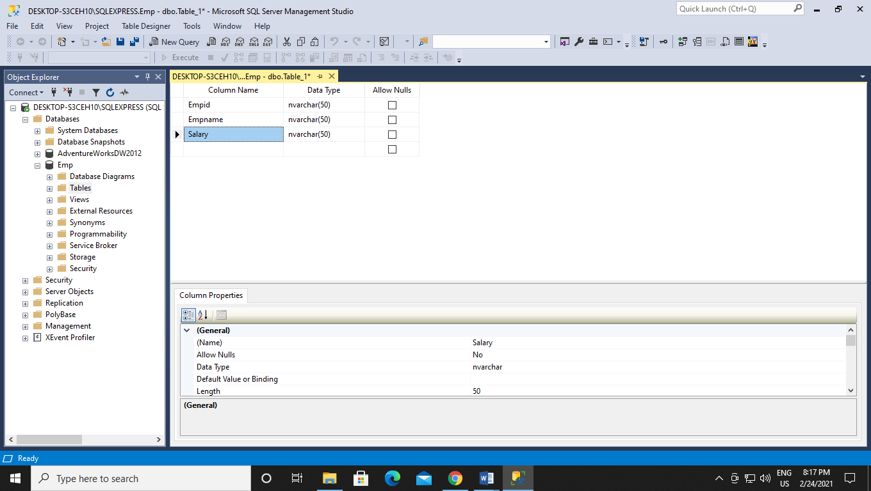

Step 5:- set Empid to primary key.

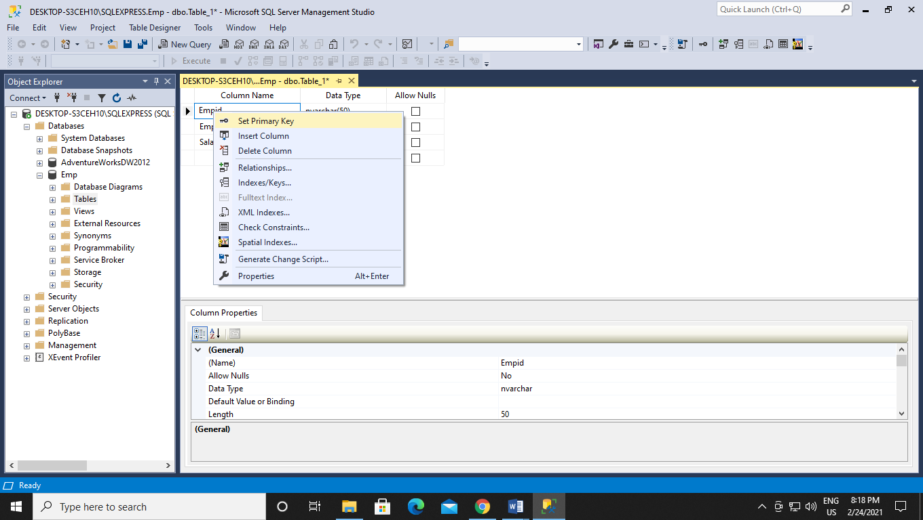

Step 6:- than press ctrl + s to save the table and enter the name of the table .

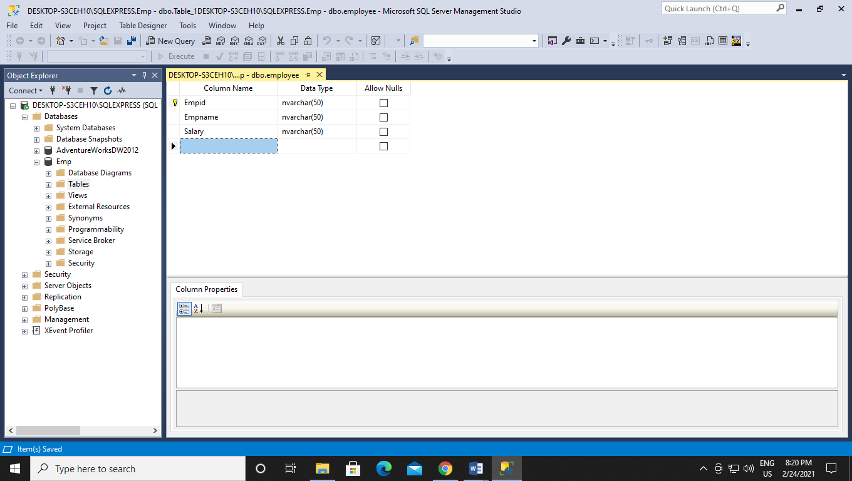

Step 7 :- now open new query and type SELECT * FROM Employee; it will show the schema of the table as there is not data.

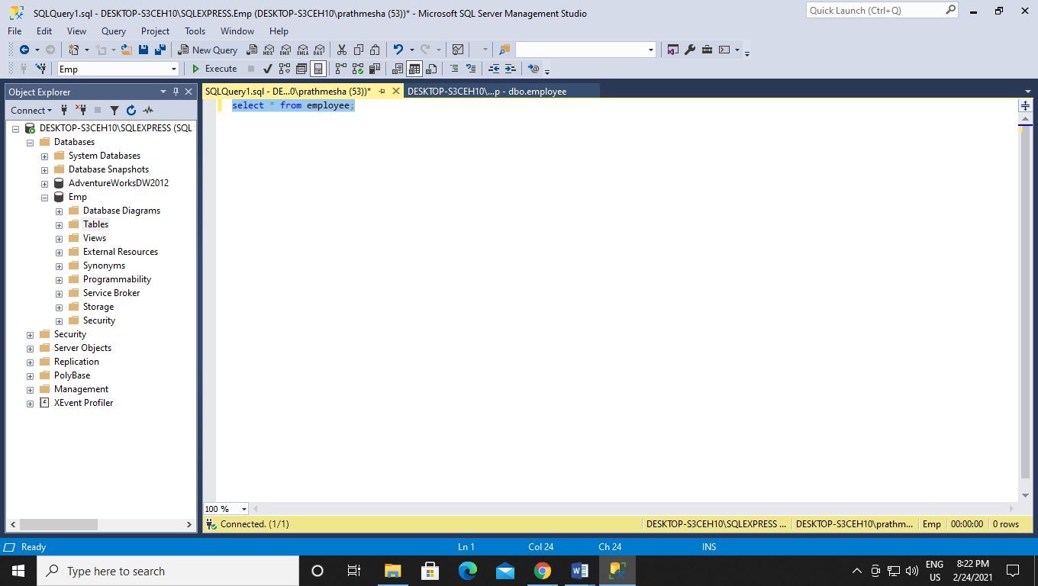

Step 8 :- Now open SSDT and than start a new project and select Integration services.

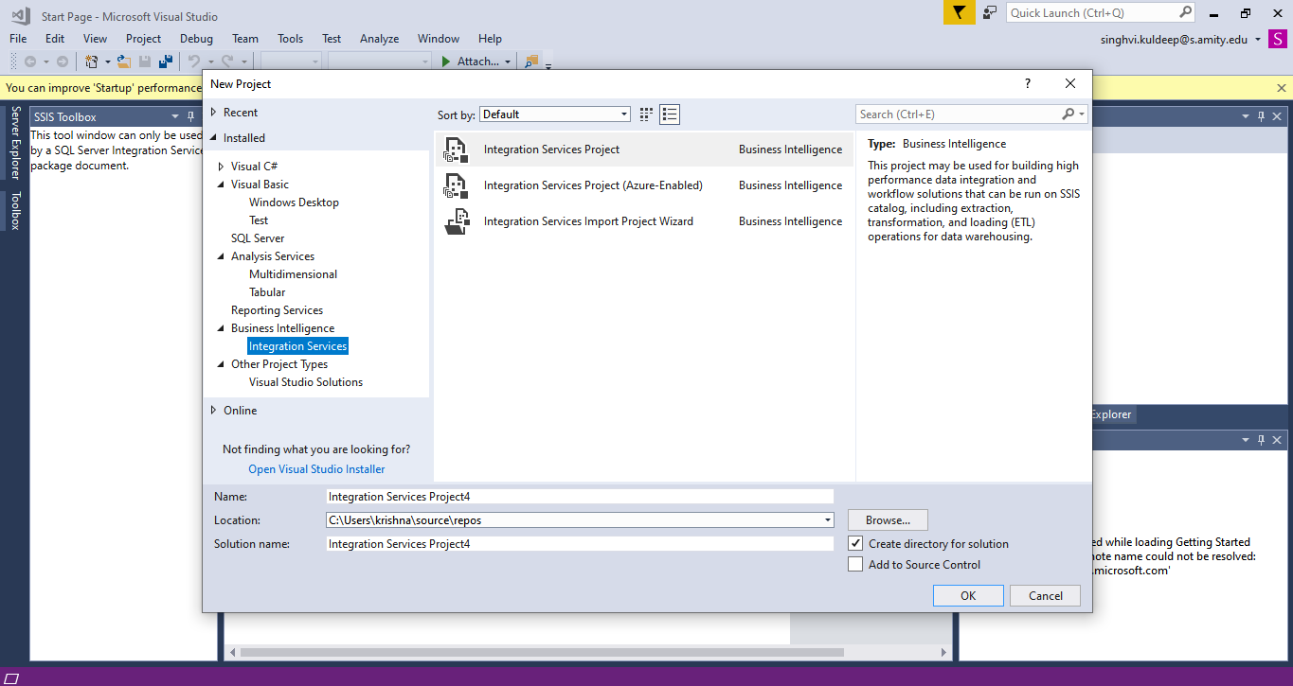

Step 9 :- Now drag and drop the data flow task in create flow than double click on data flow task.

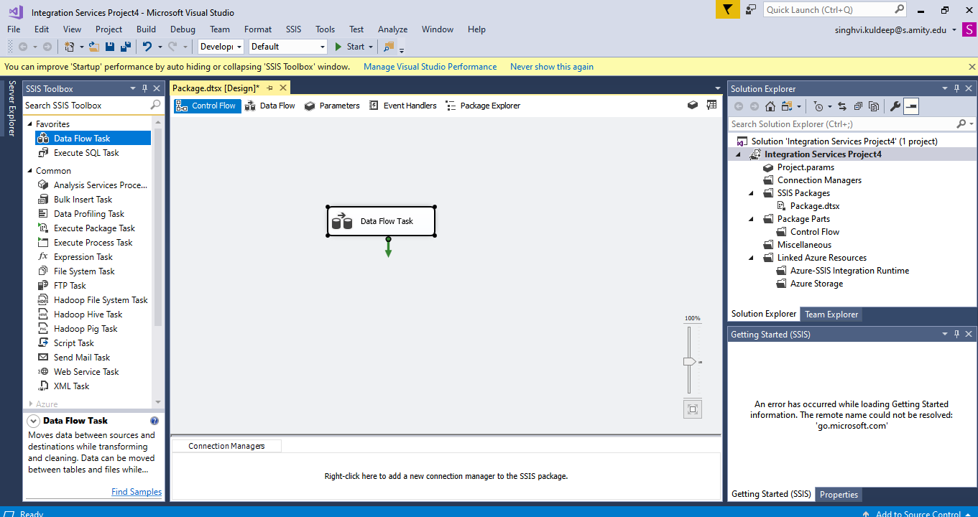

Step 10:- now from other services choose flat file service as we going to take data from csv file .

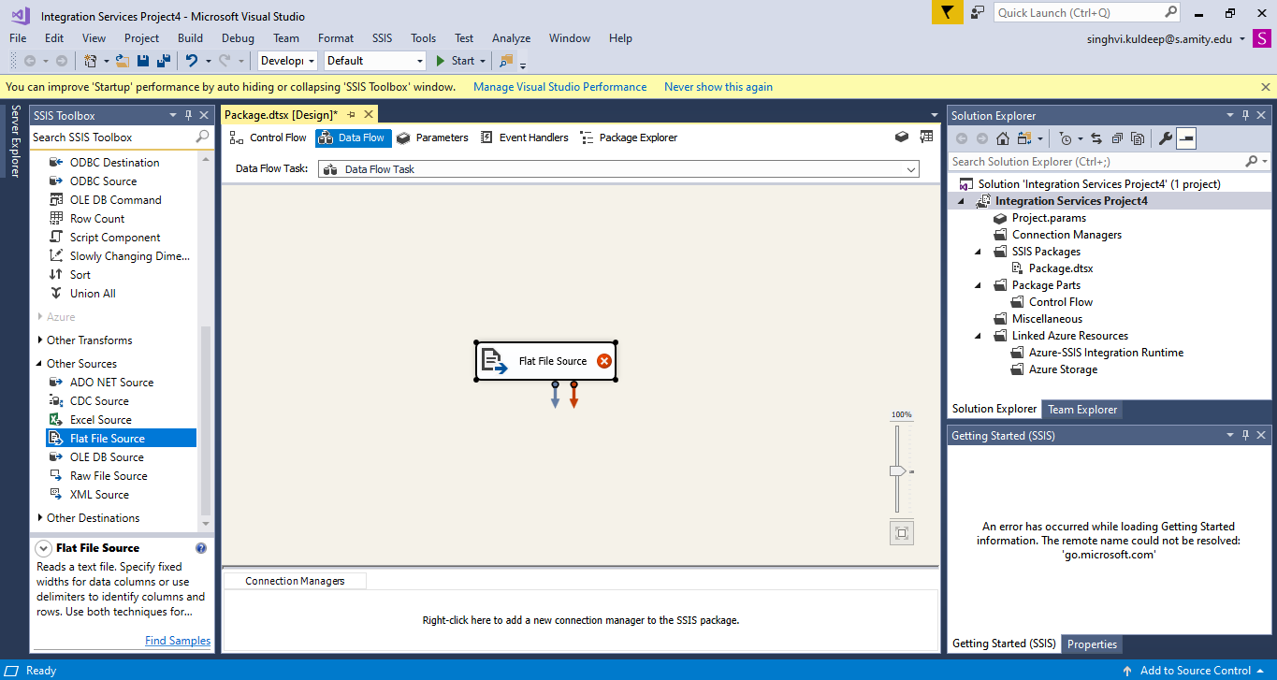

Step 11:- now click on flat file source and select edit.

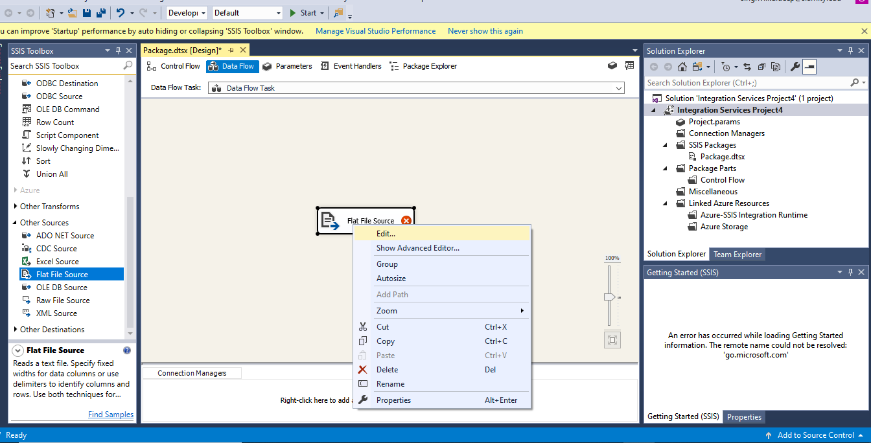

Step 12:- As this is our first project there is no save connection . so we click on New .

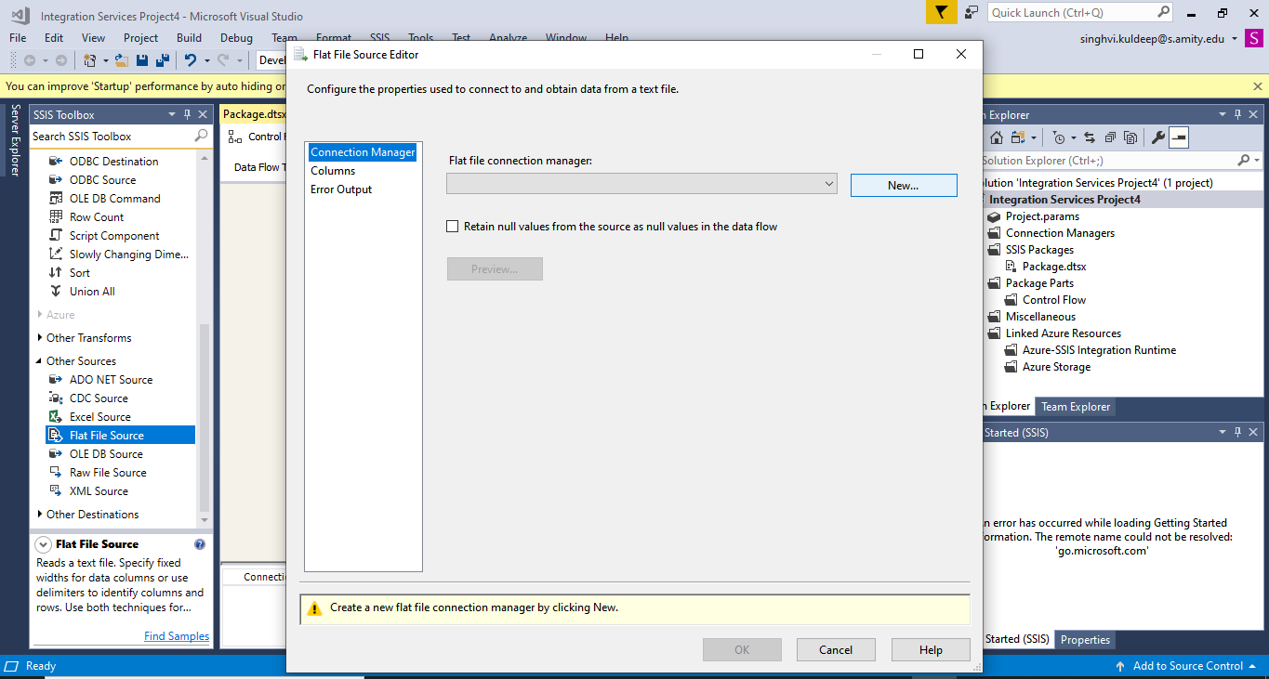

Step 13:- now first we have to write the description than browse the file(.csv) from which we have to extract data than click ok.

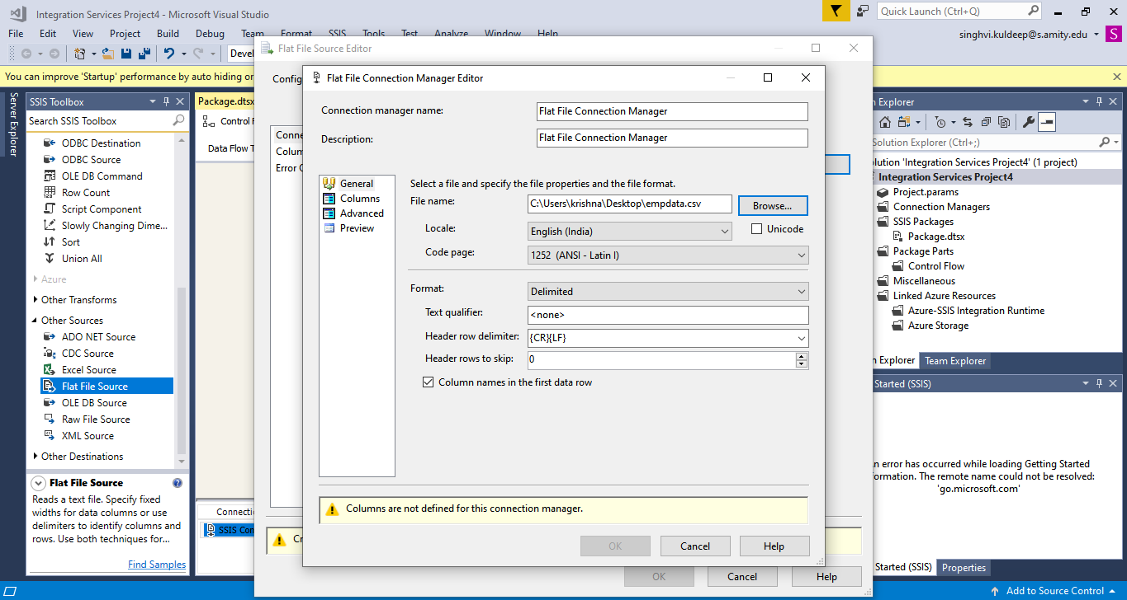

Step 14:- after setting the connection we can check what data that file content by going in column section.

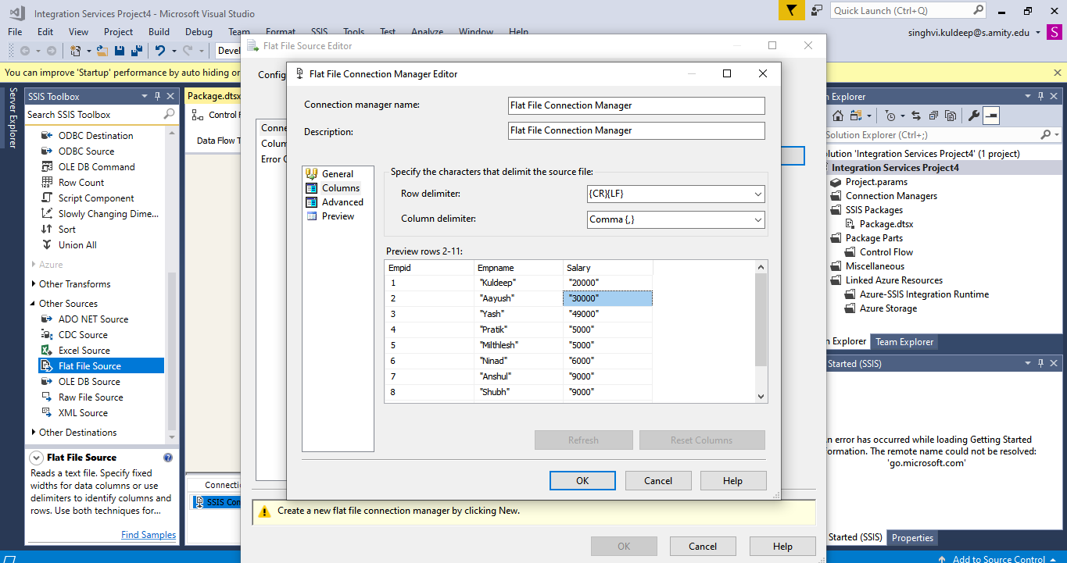

Step 15:- we can also check the data in preview section.

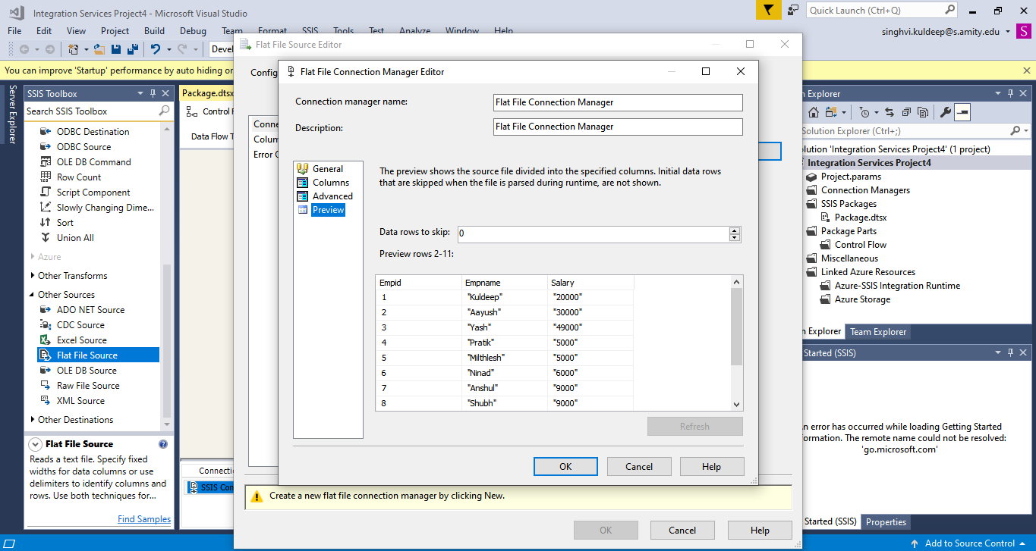

Step 16 :- now we have to check if the same column data if going to get copy in the column so we arrange the external column and output column according to same name.

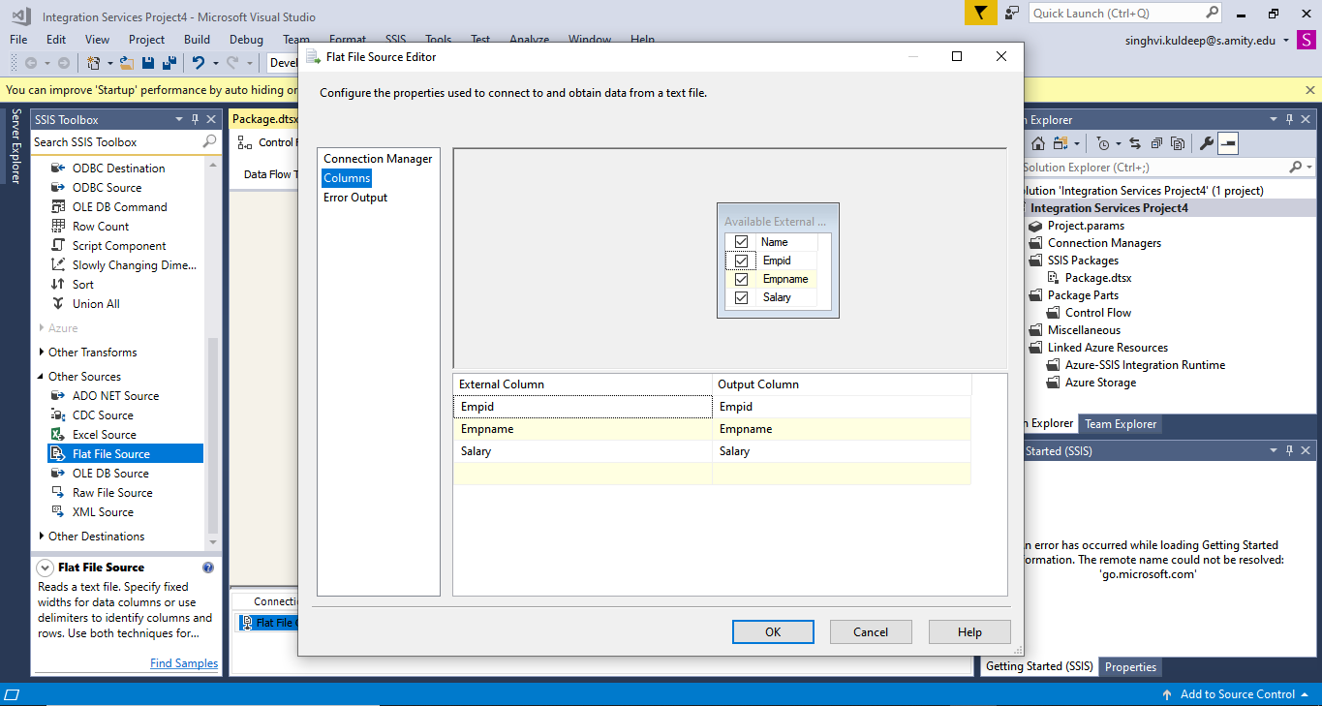

Step 17 :- Now from other destination we click ADO net databases as we are using Microsoft sql server table as our end destination.

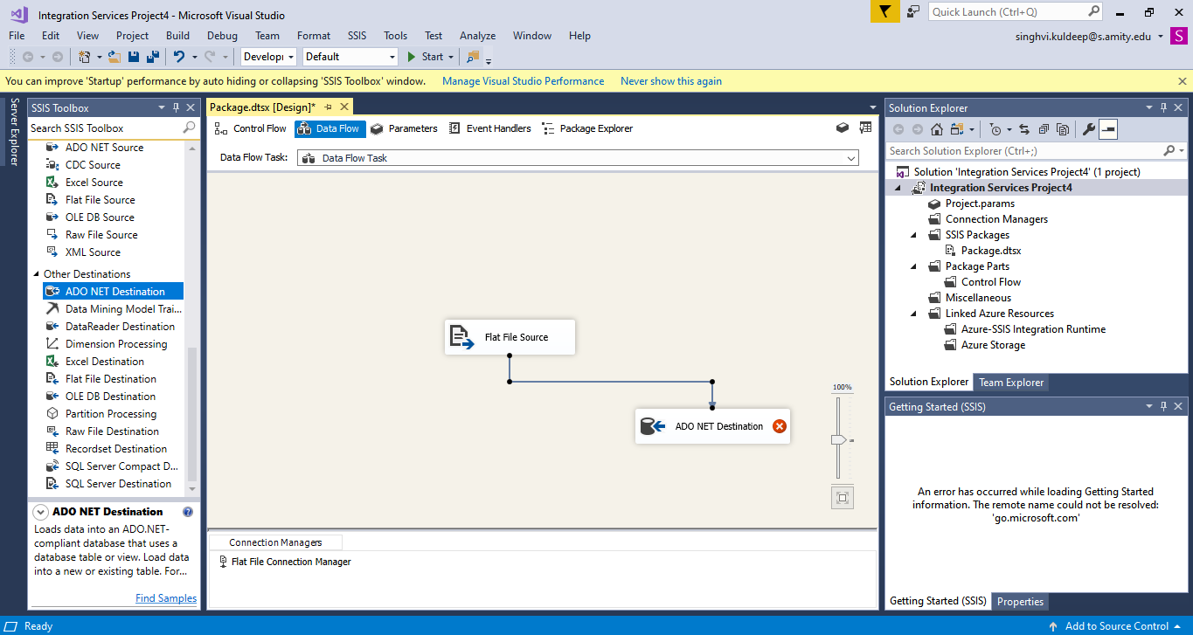

Step 18 :- now click on the ADO net database and now use our server name and select the table in which the data is going to be filled. Than click ok

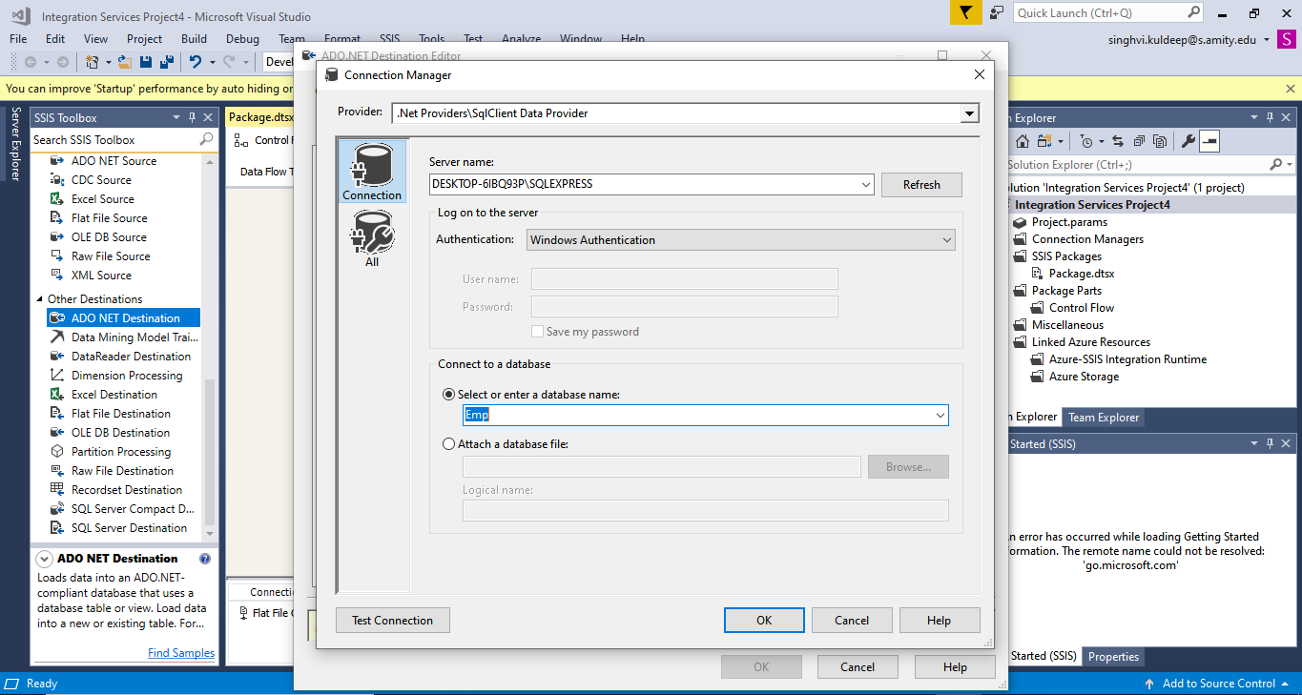

Step 19 :- here we can check the database and table name if they are correct or not.

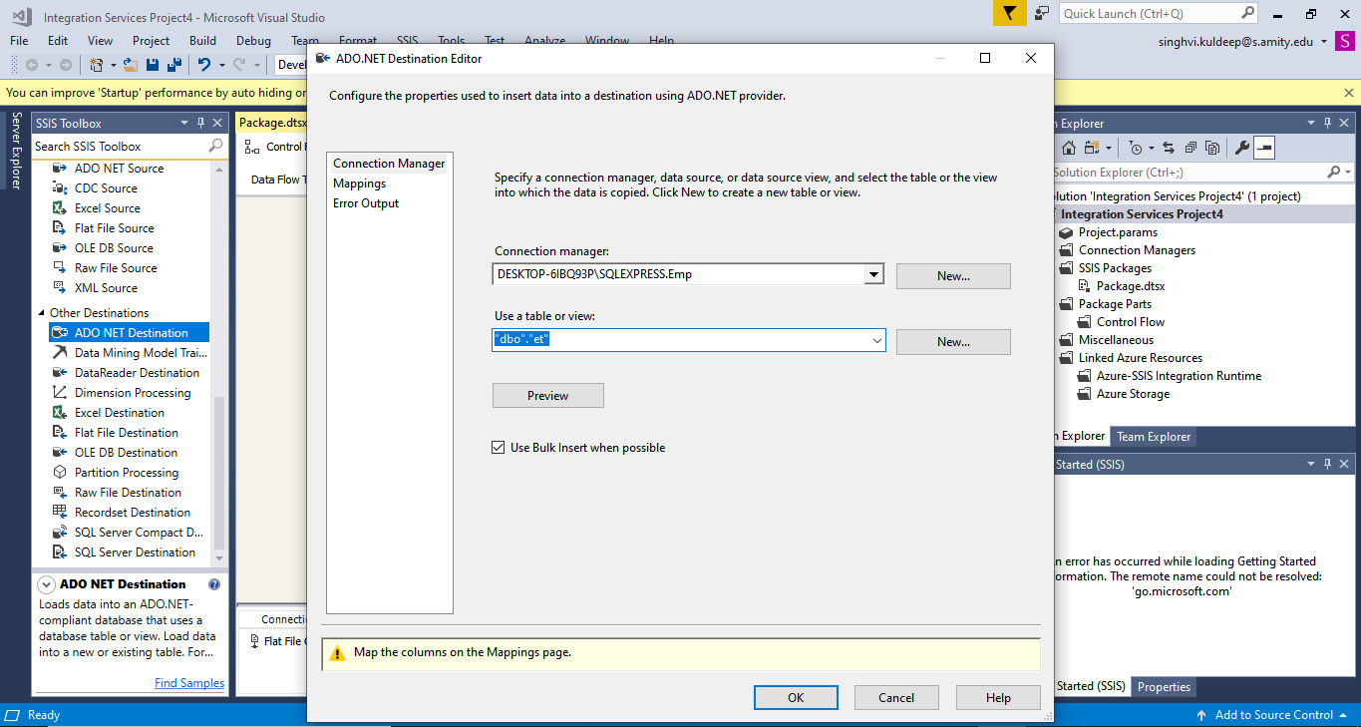

Step 20 :- Now we can go in mapping to check the column name if they match for input column and destination so the data is transferred correctly in the column.

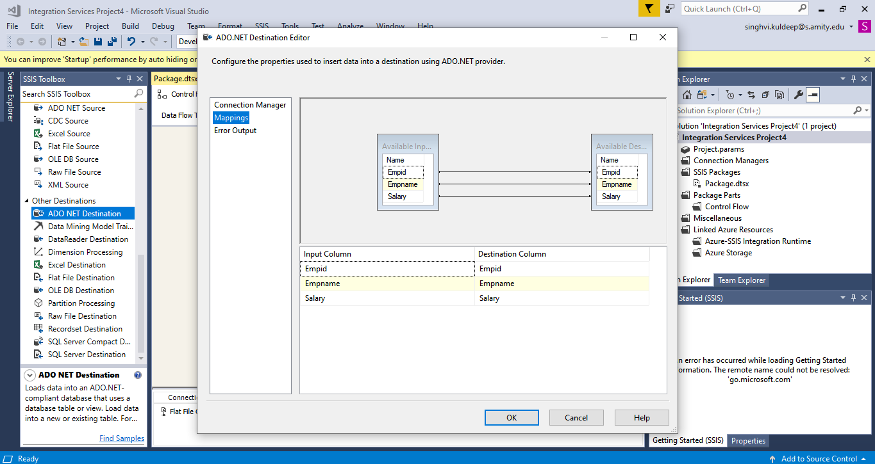

Step 21 :- click on start .

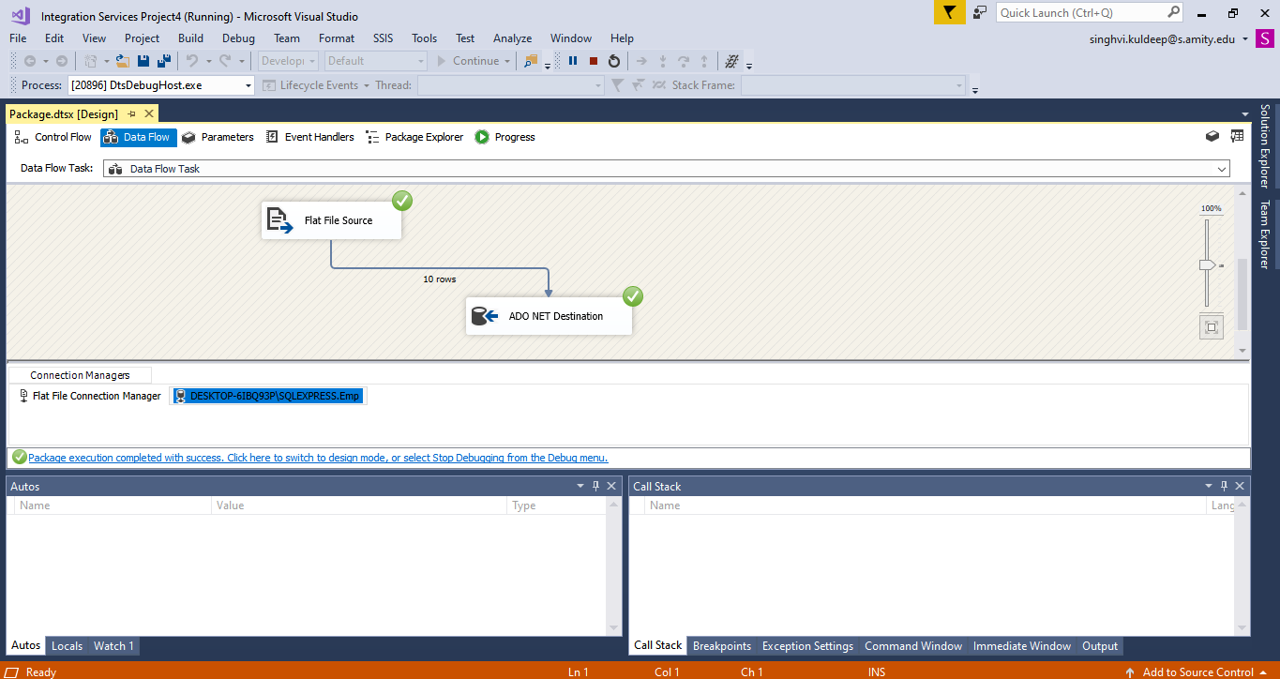

Step 22 :- the process was successful so we can see the data in the sql server table.

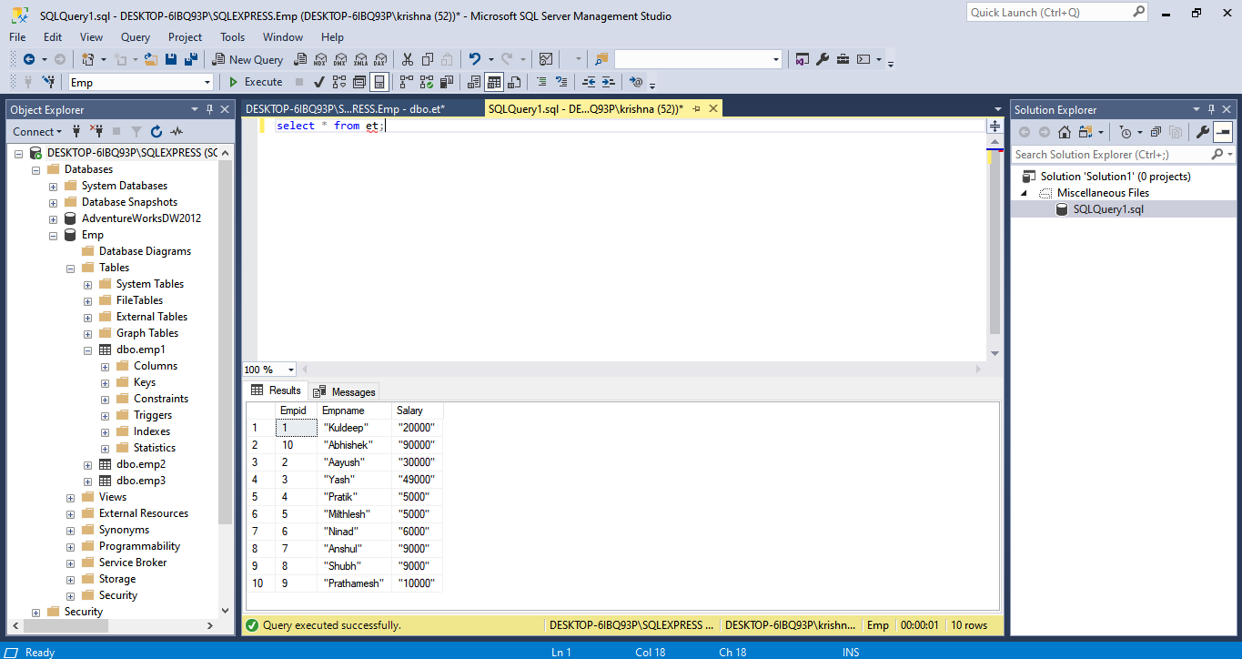

Step 23 :- first delete the table by using delete et in sql server .

Than erase the click of flat file to ADO . than from common transformation setect derived column.

And than link flat file to derived column and than to ADO.

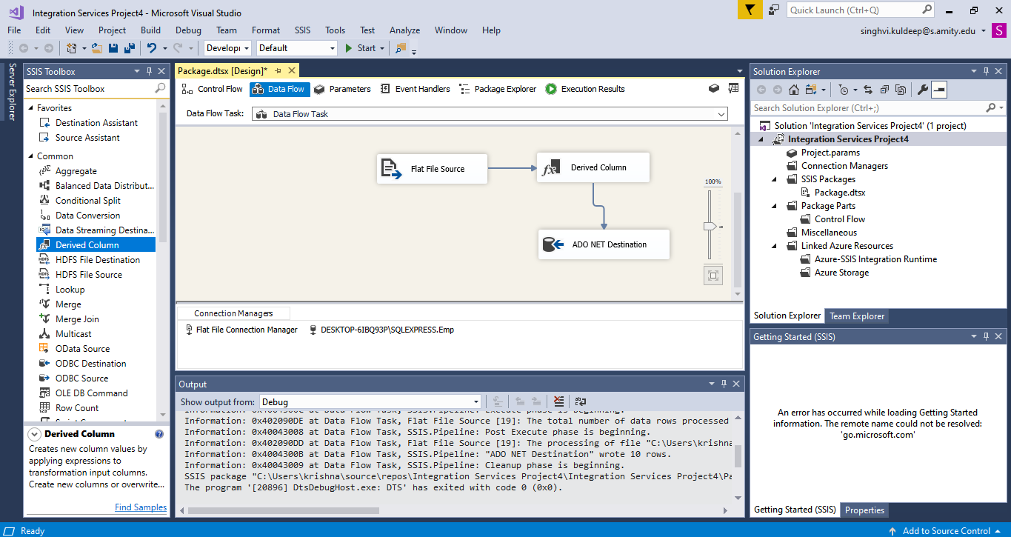

Step 24 :- Now we select what transformation we have to do and on which column so we select

Empname and convert all the data into uppercase

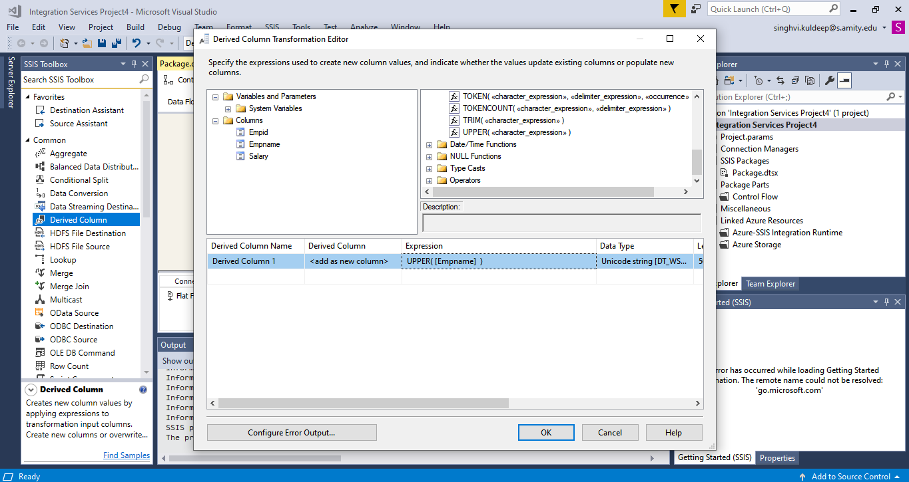

Step 25 :- now we select derived column data to be sent to empname in destination .

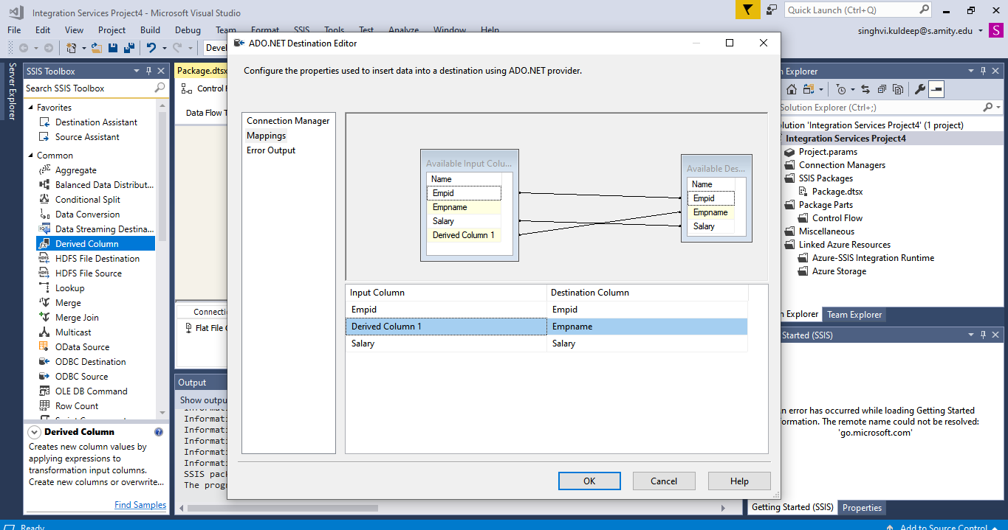

Step 26 :- Click on start.

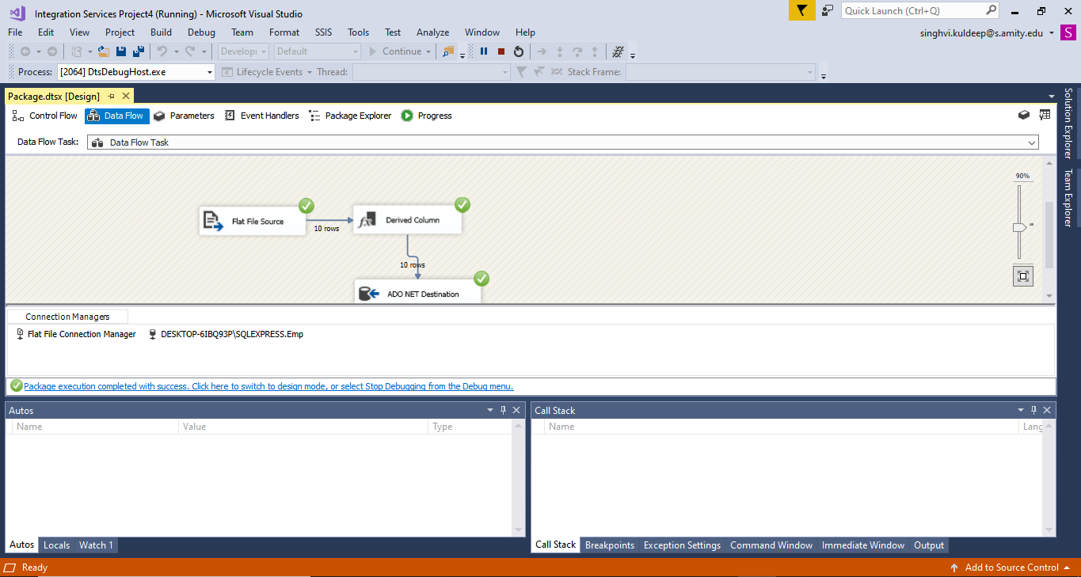

Step 27 :- now we go to sql server and execute select * from employee . as we can see the data in empname are in uppercase.

